Logo SALTO De Ontmoeting

INFORMATIONBOOKLET KINDERGARTEN

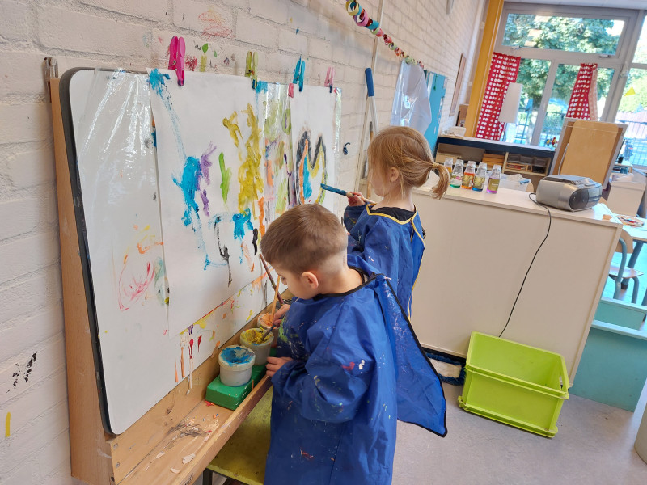

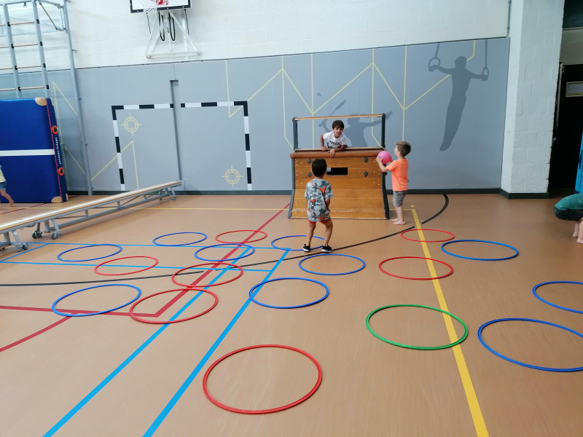

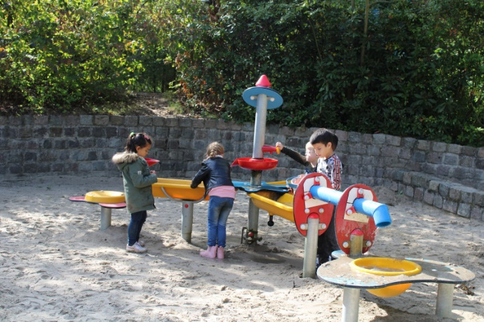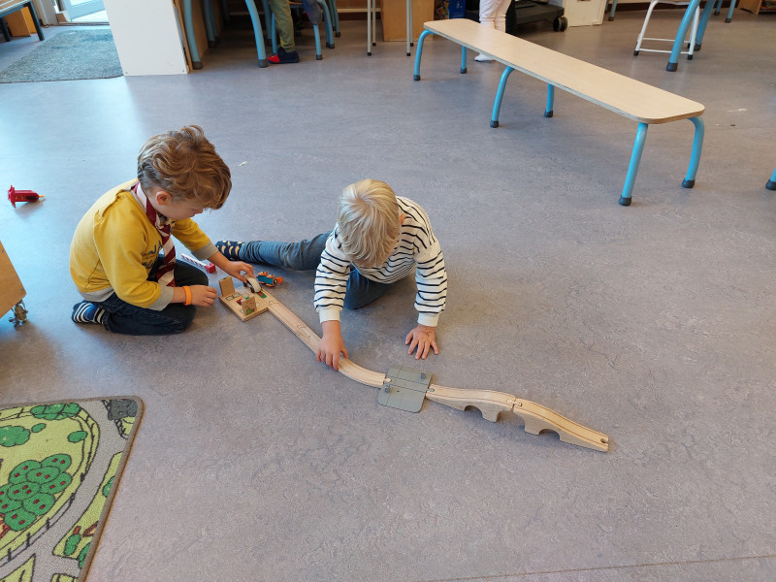

Saltoschool de Ontmoeting I Hettenheuvellaan 2a I 5628 DP Eindhoven I 040 2414663 I info@bs-ontmoeting.nl

I www.bs-ontmoeting.nl

INTRODUCTION

With this booklet we want to inform you about the daily routine in the

groups of our school. You will find practical tips, and moreover we can explain a number of agreements.

For more detailed information about our school we refer you to the school guide and the calendar.

SCHOOL TIMES

Monday, Tuesday, Thursday and Friday:

8:45 a.m. - 2:30 p.m.

Wednesday:

8:45 a.m. - 12:30 p.m.

GOING TO SCHOOL FOR THE FIRST TIME

Just before their fourth birthday, your child has already spent up to five mornings

visiting’s to get used to the other children and the group leader.

Your child is subject to compulsory education at the age of 5, but may attend school from

the age of 4. Your child will be obligated to attend school at the age of 4.

It is important to get your child used to the daily rhythm of going to school.

Let your child only stay home in consultation with the group leader or in case of illness.

LEAVING

The first step across the threshold is usually difficult: for the child, but also for

the parents. Saying goodbye will not always be easy,

but that is also understandable: All unfamiliar faces and a strange teacher.

Say you are leaving and give your child a big hug. Tell him/her you will see them

later and leave immediately. This is difficult, but try anyway.

It is important for the group leaders to be able to start lessons on time and quietly

begin. Occasionally a child may need to cry, but usually that is over after a few

minutes. If it is not possible to calm down during the day, we will call you to ask you to pick up your child earlier.

WALK-IN QUARTER

In the morning, children and parents/caregivers may enter from 8:30 am.

There is a walk-in quarter until 8:45 am.

During the walk-in quarter you can play along and your child can show what has been done/made. There may be time for a brief announcement to the group leader.

Please arrive on time, as we would like to start at 8:45.

If you do happen to be late, please say a brief goodbye to your child in the hallway and let them gently enter the classroom.

If you would like to speak to the group leader, please make an appointment to defer until after school.

ILLNESS / ABSENCE

If your child is ill or will be late, for example due to a doctor's visit, you are

requested to notify the school before schooltime by phone or an email to the appropriate teacher.

Phone number: 040-2414663.

In case of contagious diseases, we urge you to let the school know as well. Of course in the best interest of the other children and the group leaders.

If you notice head lice at your child it is important to inform the school as soon as possible. Your child may return to school after treatment.

After each school vacation all children are also checked at school for head lice.

BIRTHDAY!

Every birthday is a big party and will be celebrated and of course your child hand out a treat!

If you wish you may join the party in consultation with the group leader. If you do not join this, we will place some nice pictures of the party on the ISY app. Invitations for children's parties may not be handed out in the classroom. This is to avoid disappointment with children who are (almost) never invited.

OUT OF SCHOOL

Please be on time when school is out to pick up your child.

The children in grades 1-2 will be picked up from their class on the outside of the emergency door.

If necessary, agree with your child on a set spot where you or another caregiver will always be.

Are you coming by car? If so, please do not park it along the yellow line because of the safe crossing of the children!

PLAYTIME AND GYMNASTICS

At school we have a gym where we like to play with different

movement games, climbing tools and other gym equipment.

It is nice if your child has good fitting gym shoes for this,

preferably with velcro or elastic.

If your child can tie them properly, lace-up shoes are no problem.

The gym shoes remain, marked with name, in a basket at school. If there are no gym shoes at school, we will practice barefoot.

CELEBRATIONS

There are regular celebrations at our school. If you

may be present, it will be announced in the Newsletter or ISY app.

You will also find these dates on the calendar and on the website.

BREAKFAST

Your child may bring drinks and a small snack for the morning. Preferably fruit. Please do not bring too much: it is not a meal. If your child brings fruit, make sure it is already cleaned or peeled. Also put the name on everything. No candy, chocolate or soda is allowed.

PARENTS AND SCHOOL

If you want to know anything about the school or about your child, please feel free to inquire.

Just make an appointment for that during the walk-in before school. After school, the group leader will have time to exchange ideas with you.

Some activities are not possible without the help of parents.

Therefore we appeal to the parents in various activities

(grandparents and babysitters may also sign up, of course!).

The group leaders and certainly the children, are very grateful if you

sign up!

If we need craft materials, plastic bags, or changing clothes for our undergrad we will put out a call through ISY.

At school we use the ISY parent communication app. Through ISY, you as a parent will receive all information from your child's class and general (newsletters, help calls, sign up for report cards, etc.).

You will receive a letter with information and a registration code to access the ISY portal. Or a sign-up link through the mail.

TOYS AT SCHOOL

Young children like to take something familiar about themselves in unfamiliar situations, such as a stuffed toy or favorite toy.

But ...... at school there is no time to play with it. Moreover, there is the

danger of getting lost or broken. That is why we ask you to make sure

that your child does not bring toys to school.

INDEPENDENCE

Teach your child to dress and undress herself. This takes more time, but

is very satisfying when it works.

When your child comes to our school, we expect your child to be potty trained.

It is not feasible for our group leaders to change a child regularly.

Should it turn out that your child is not yet potty trained, we as an elementary school want to discuss this with you. In extreme cases, we will not place your child until he or she is truly potty-trained.

It may be that your child is not yet potty-trained due to medical reasons.

In that case we kindly ask you, before your child comes to school,

to discuss this with the appropriate group leader with whom your child will be placed in class.

Children cannot be forced to be toilet trained.

However, even before their child reaches the age of 4, parents can call on the help and advice of the Child Welfare and Education Office if toilet training is not yet successful.

Of course, accidents do happen from time to time.

This can happen and is not a big deal. For this we have clean clothes at school. We also ask that you put a changing kit in your child's bag.

AND FINALLY:

We wish your child a happy school time and hope for a pleasant cooperation with you as parent(s)/caregiver(s)!